ASSIGNMENT-1

Dhruva choudhary jampani

Python training(04/03/2019)

1 - Write a program to take input f rom user using fol lowing approach:

raw_ input()

raw_ input() with type conversion

raw_ input() using eval

input() in version 2

input() in version 3

Also, return the datatype of all variable.

Answer:

Raw_input with eval and type conversion:

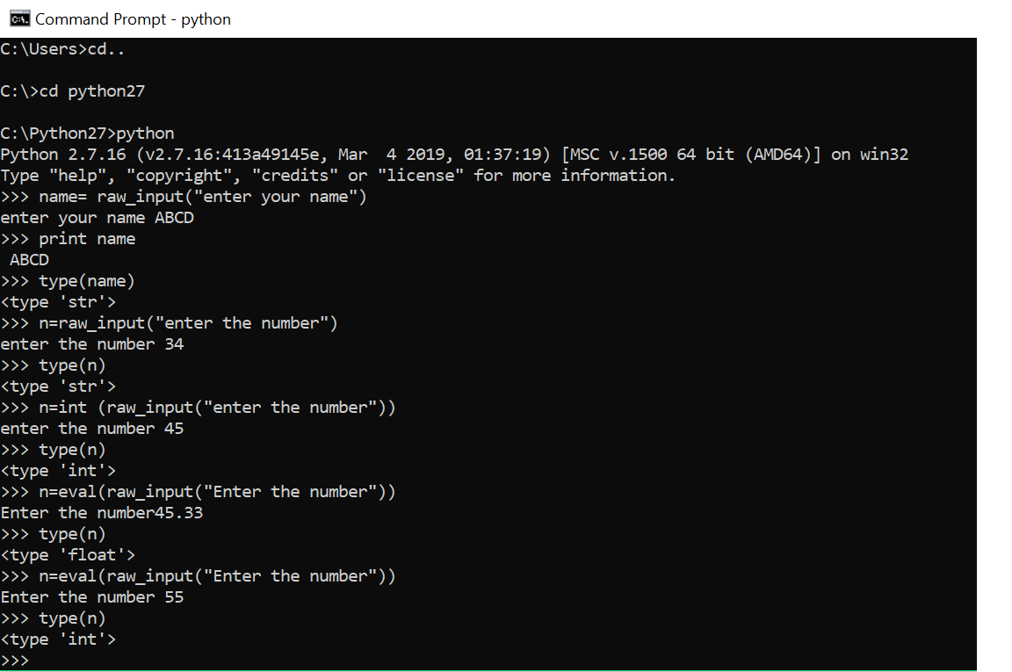

INPUT in version2:

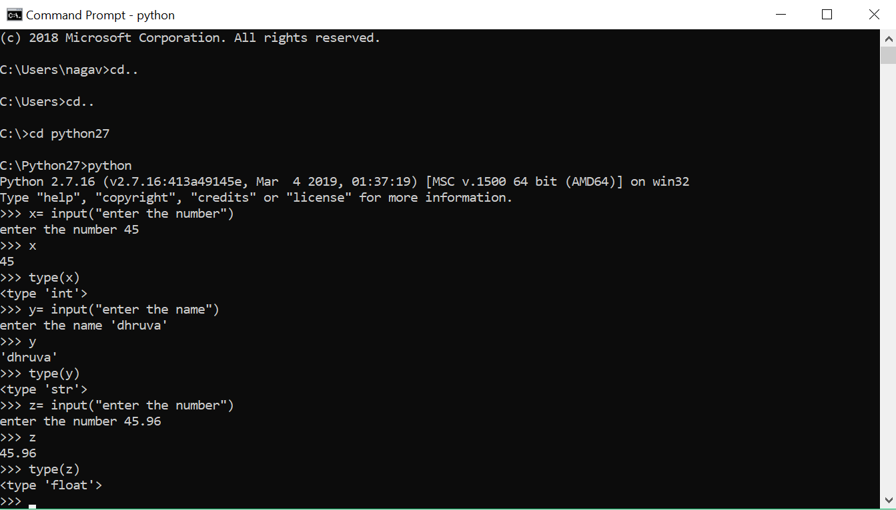

Input in version 3:

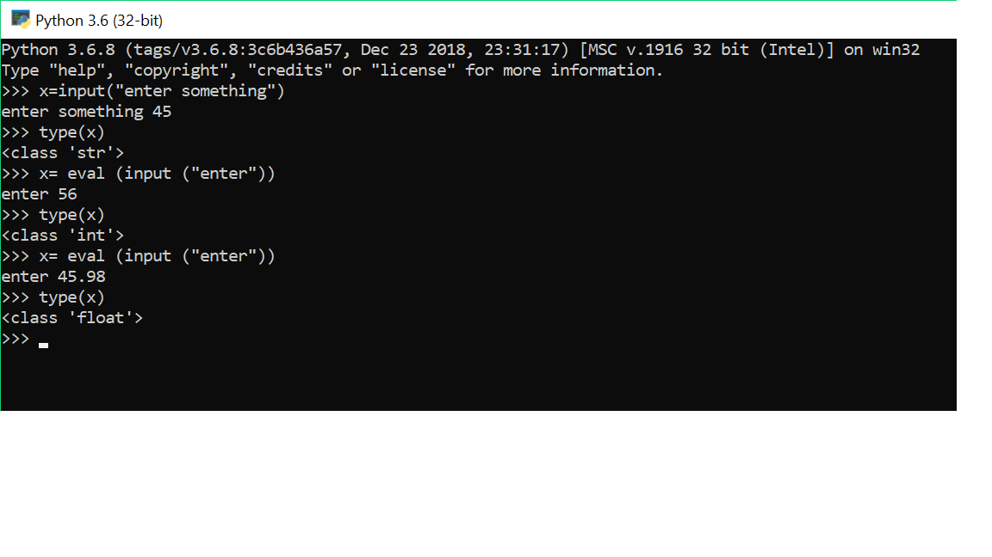

1. - Write a program to print the statement given, fol lowing are the statement

Hello! My name i s XYX

" Hello I am a candidate"

" 234 . 56 "

" 34 "

a+ 3 j

Answer:

Version2:

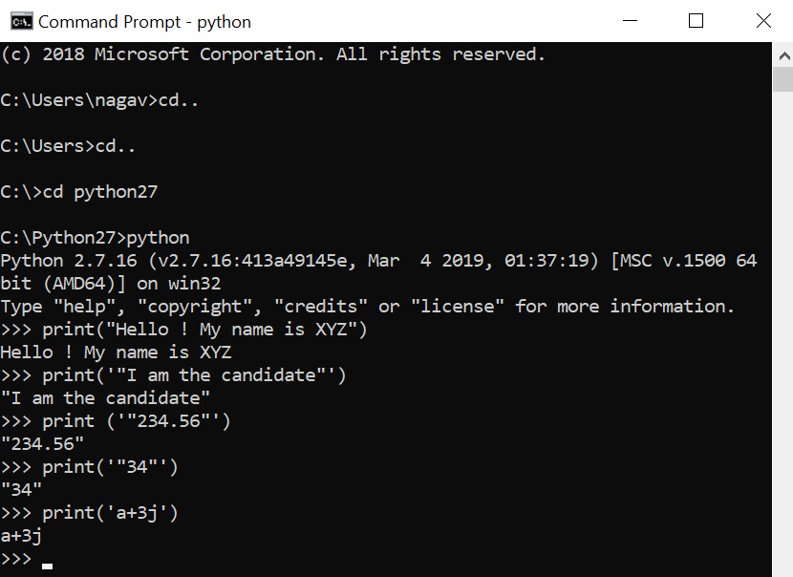

Version 3:

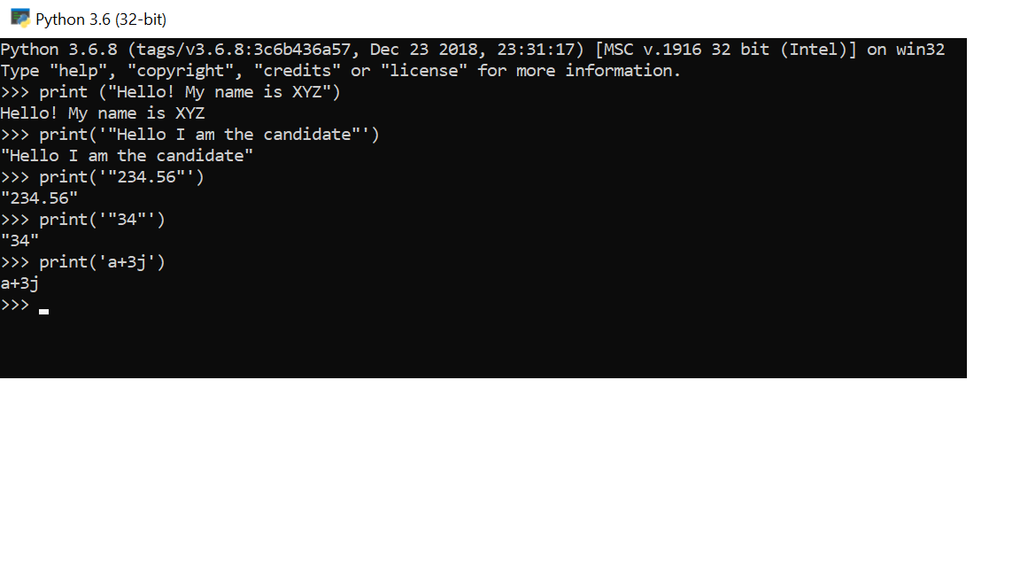

1. - Solve the fol lowing expression and return the data type of the variable

x= 10 + 20 * ( 45 + 67 . 0 )

x= ( True AND False) OR False

x= ( TRUE OR TRUE) AND ( NOT False AND True)

x= ( 3 > 89 ) OR ( 34 > 32 )

x= NOT True AND False

Version 2

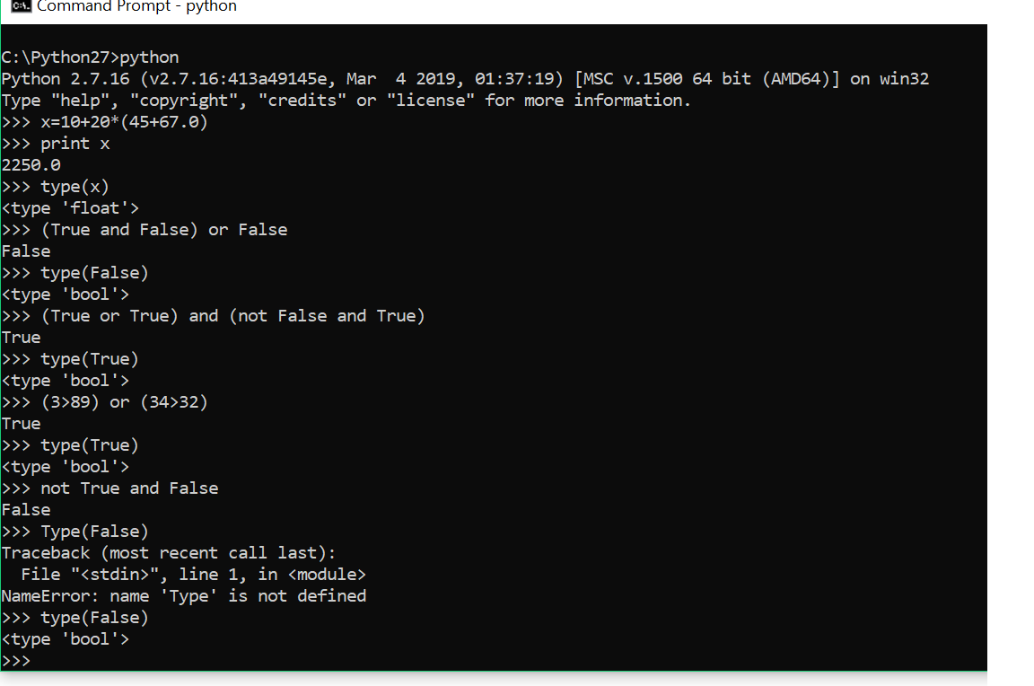

Version3

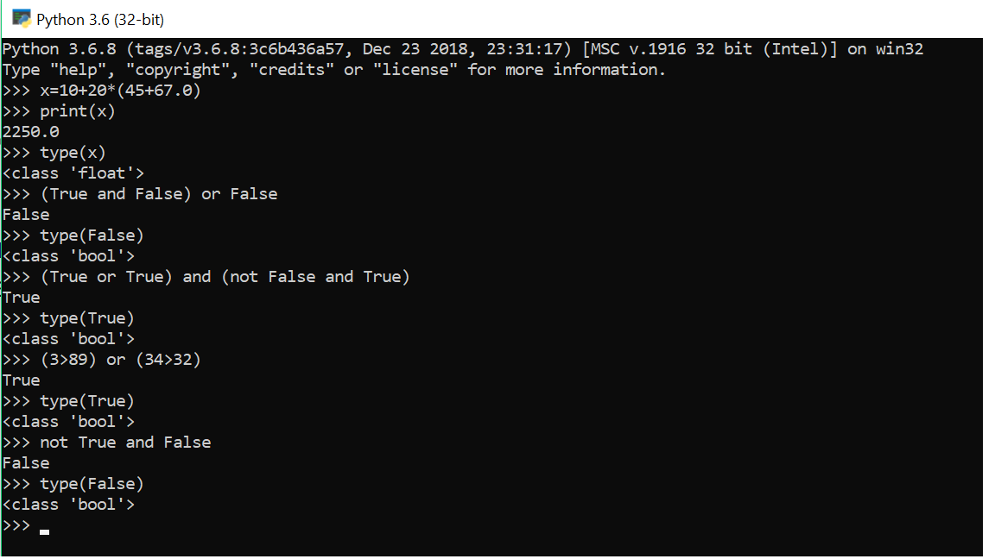

1. - Write a program to print " Hurray i t i s what I am looking for" i f the number i s divisible by both 2 and 5 and i f i t i s not and print " wrong input". Make sure that you al low user to input the value f rom keyboard.

Answer: Version2:

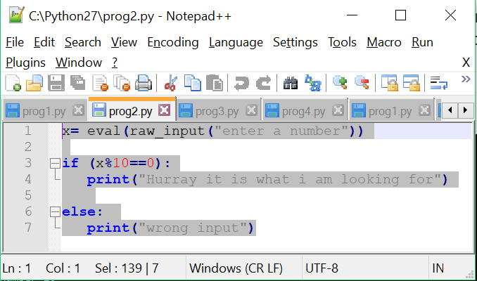

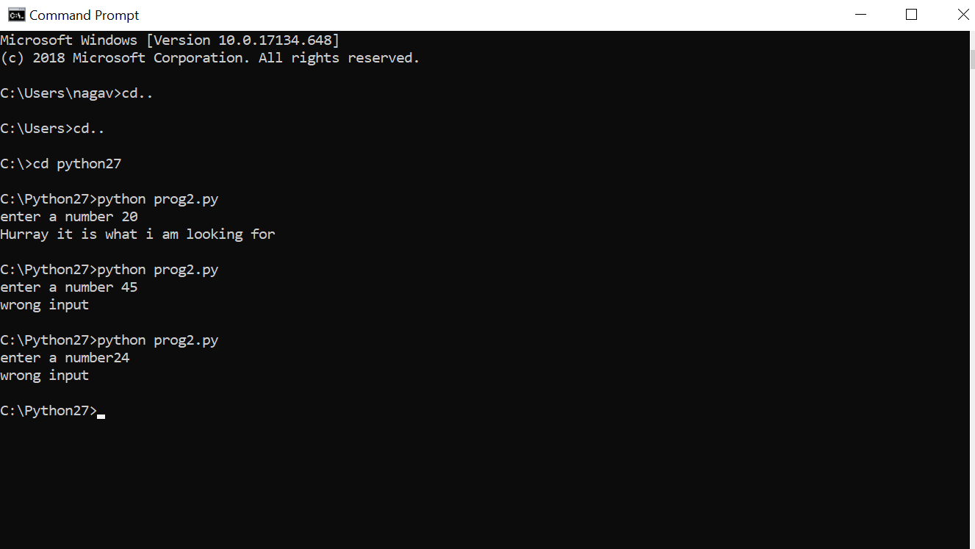

Version 3:

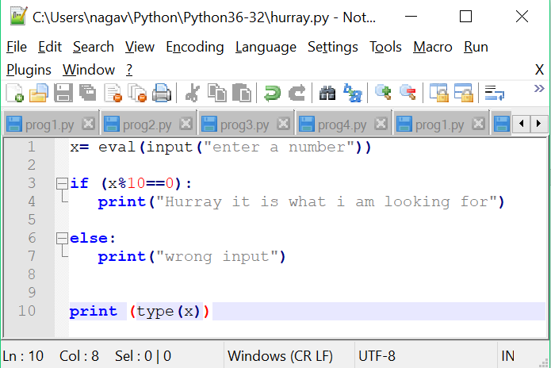

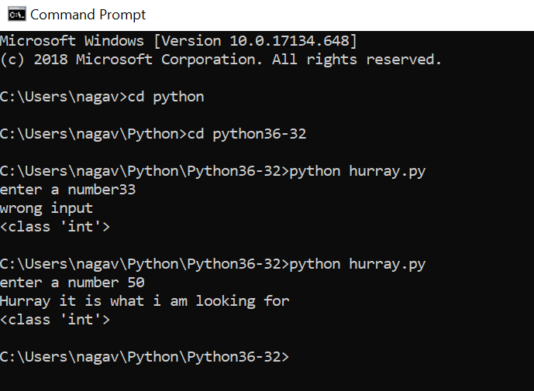

1. - Write a program to enter the number and print " Yes I am in the range" i f i t i s in the range of 10 - 50 i f not and then print " Oops".

Answer:

Version 2:

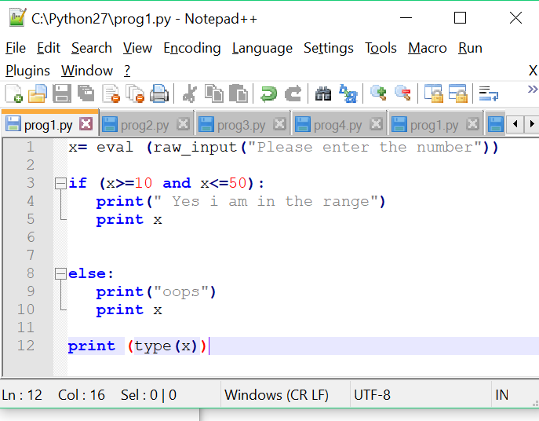

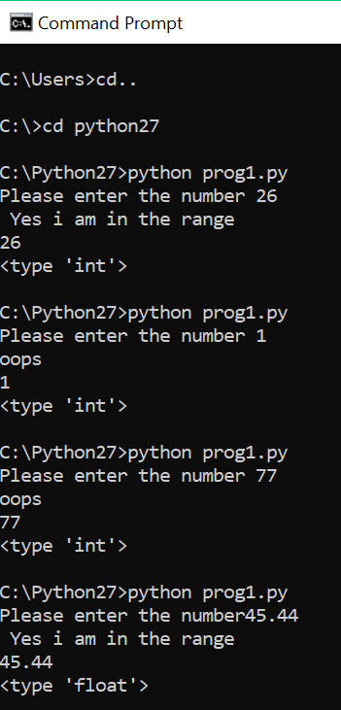

Version 3.6:

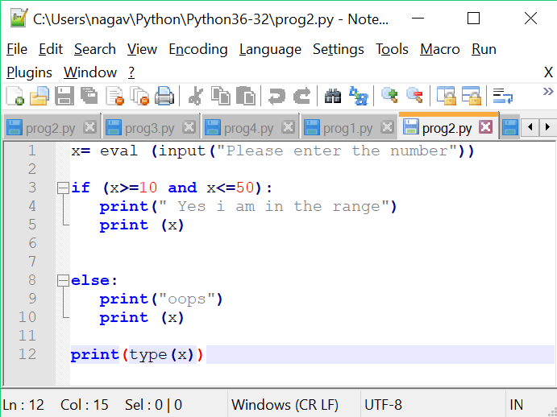 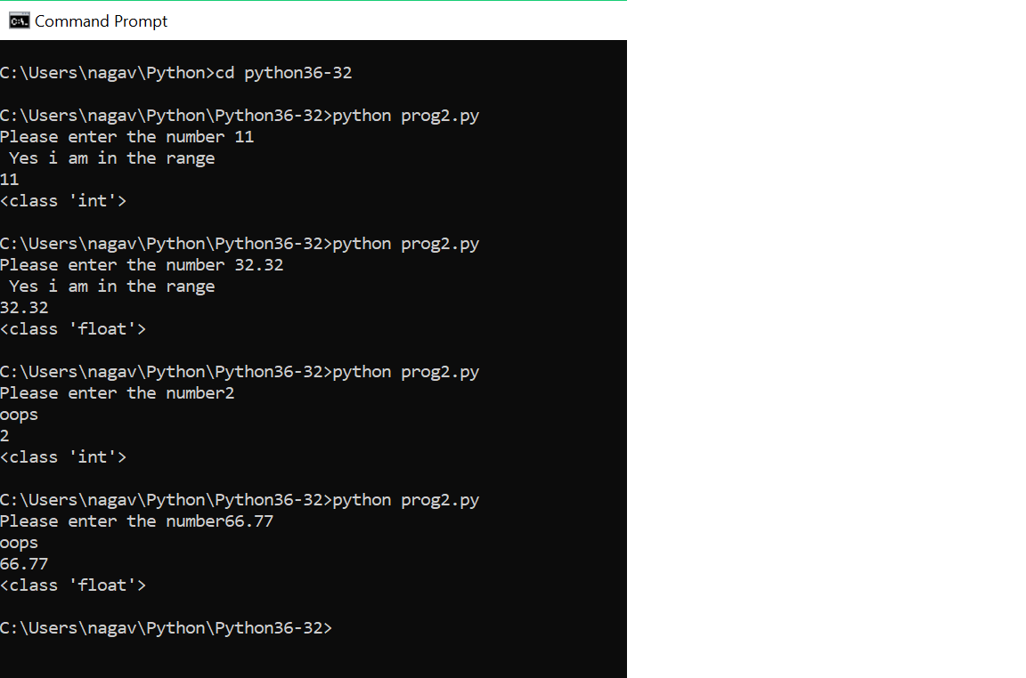

1. - Write a program to implement the nested and ladder i f else condition.

Answer: Nested if else:

Version 2.7:

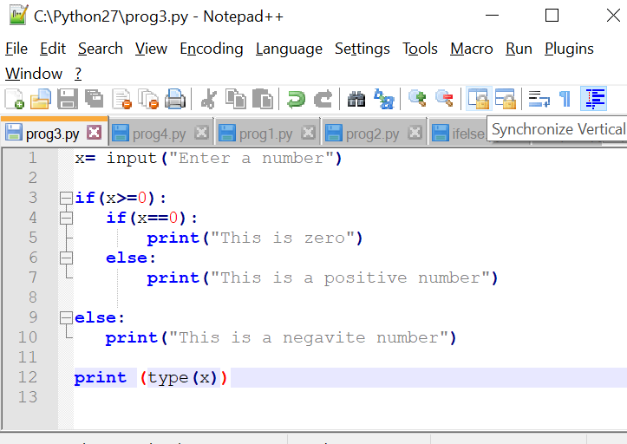

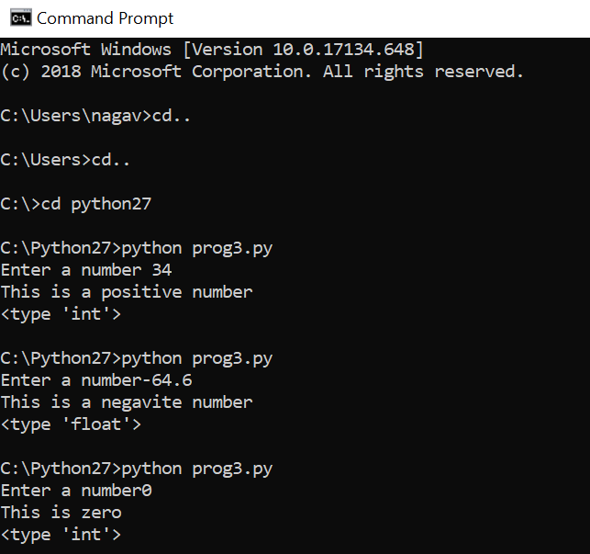

Version3.6:

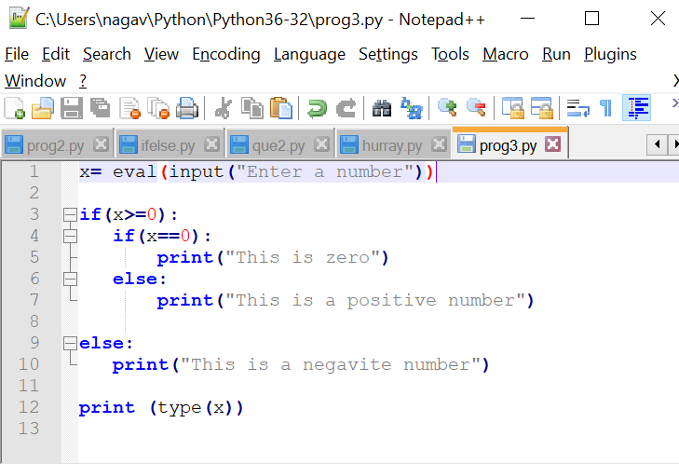

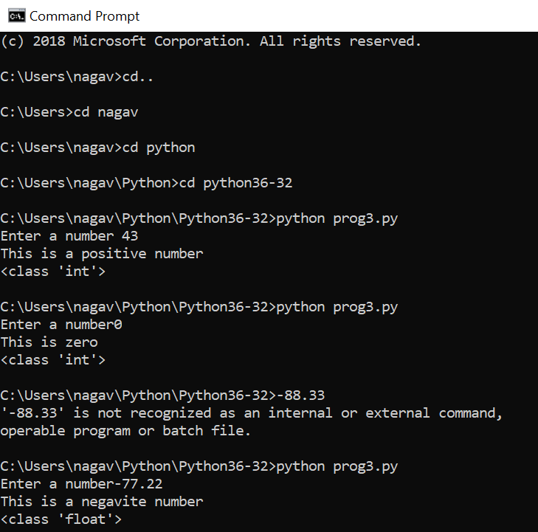

Ladder if else:

Version2.7:

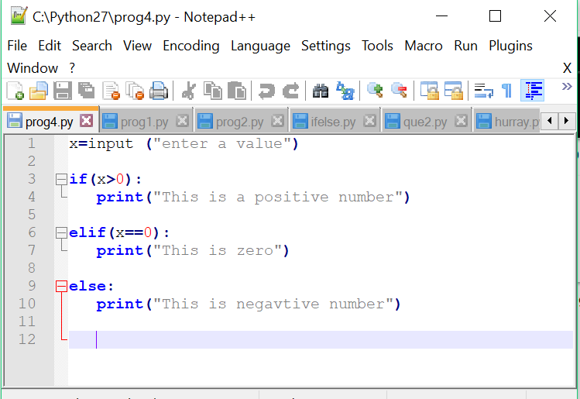

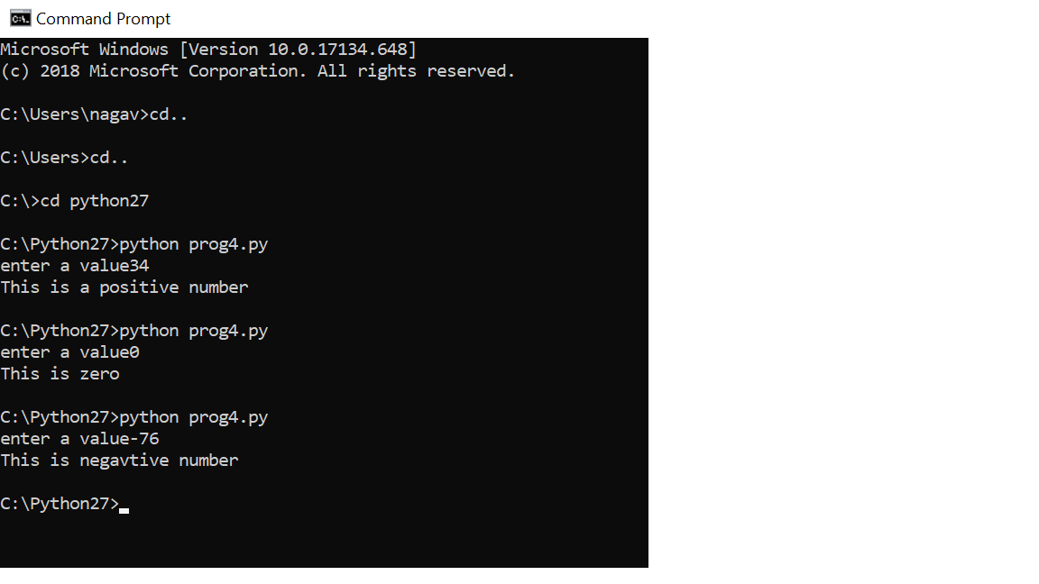

Version3.6:

